Product Choices
- Demonstration
- Electronic portfolio
- Essay
- Exhibition
- Journal
- Research paper
- Presentation
- Portfolio
- Performance
- Test

Tic Tac Toe Choice Board
Complete a row of three squares

Change the setting of the novel. Describe how this setting would change the story and why. | What do you think about the motives of at least three of the main characters? Why do you think they drive these people? | Choose a passage and find ten words you do not know that you think are important to what is being discussed in the passage. Making a glossary so that others can reference it or create flashcards for them.
Write a diary entry or draw a picture of a scene from the perspective of one of the minor characters. How might they see what is going on in the book differently than others? | Student choice | Write a song for the novel that captures its main theme. You can choose to perform this or not.
With a partner answer the following questions:  - Who is the main character of the story?  - What is the problem in the story?  - What is the setting of your story? | Present a monologue, create a PowerPoint, or make a WeVideo from the perspective of one of the characters and how they view the protagonist and the antagonist. | Replace characters in the book with members of a popular television show or movie. How would these characters act in the story and would it change things?

Student Choice Board ELA

Write a letter to someone famous. | Write a poem or a rap song about a character from the story. | Make a set of vocabulary index cards that would be helpful to someone reading the book. | Devise a character web about one of the main characters in the story and how others would appear on this web.
Create a Facebook profile for one of the main characters along with a few appropriate posts. | Make a Venn Diagram where you compare yourself to a character from the story. | Create a timeline for the main events of the book. | Write a journal entry from the perspective of one of the characters.
Make a comic strip that provides the main concept of the story. | Make a cheat sheet that someone could use to write a report on the book even if they haven’t read it. | Illustrate a book cover for the story you are reading that captures its essence. | Create a “tweet” that summarizes the story (cannot be longer than 140 characters)
Plan a summary for what the sequel of the book would be about. | Imagine a new ending to the story. | Draw 5 illustrations that would be placed at important parts of the book to capture events. | Storyboard one of the most important events in the book.
Choice Board Math

M  (mastery) | A  (application) | T  (taking it to the next level) | H  (honing your skills)
Be able to explain the rules for adding decimals | Complete problems 1-5 concerning decimals. | Come up with 10 problems of your own that use the rules of decimals (provide an answer key as well) | Create a game where participants must use decimals in order to play
Watch the Khan Academy video on decimals and summarize what you learned from it | Be able to use decimals when dealing with money in a real life situation | Take a look at the sample problem and try to find where a mistake was made, correcting it | You are given $172.82. Buy yourself a back-to-school wardrobe

Menu Board

Choose an appetizer

Remember details about the lesson.

Demonstrate understanding of the lesson.

Choose a side dish

Apply the lesson to something in your own life.

Analyze the lesson and decide what information is most important to you

Choose a main dish

Create a product that demonstrates mastery of the lesson.

Evaluate the importance of the lesson to you.

Choose a dessert

Provide a reflection on something you learned from the lesson that you hadn’t expected to?

Multiple Intelligences Choice Board

Naturalist  - Field Study  - Collection  - Map | Visual/Spatial  - Collage  - Foldable  - Board Game | Body Kinesthetic  - 3D Model  - Play  - Hands-On Experiment
Interpersonal  - Interview  - Role play  - Teach | Student Created  - Choose a product that is not on this choice board | Musical Rhythmic  - Poem  - Perform Song/Rap  - Soundtrack
Verbal/Linguistic  - Tri-fold  - Brochure  - Review | Intrapersonal  - Journal Entry  - Self-Evaluation  - Discussion | Logical/Mathematical  - Timeline  - PowerPoint/Google Slide  - WeVideo/FlipGrid

I’ve Finished, Now What Do I Do?

(roll the dice to determine what you can do now that your work is finished)
Get on your Chromebook and play a game/watch a video over that concept

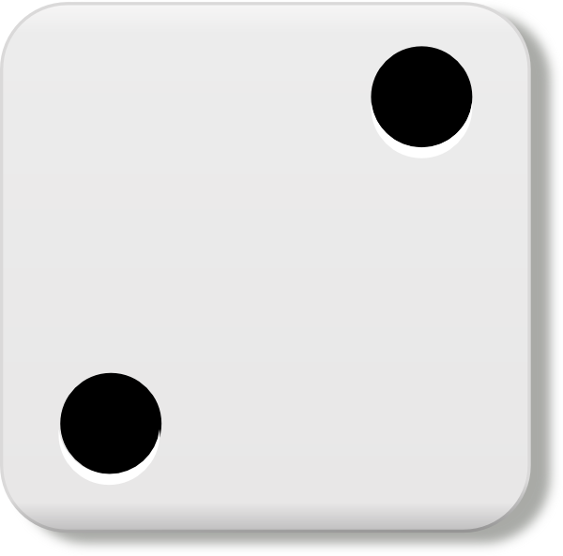

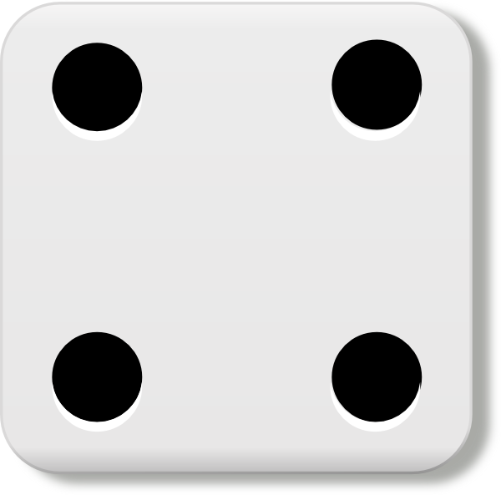
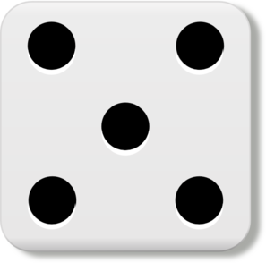
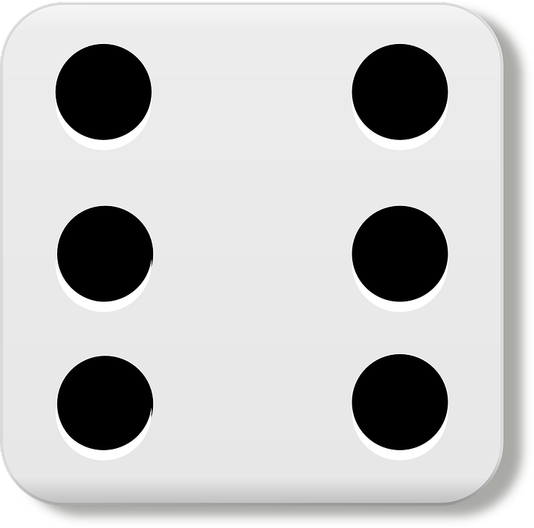
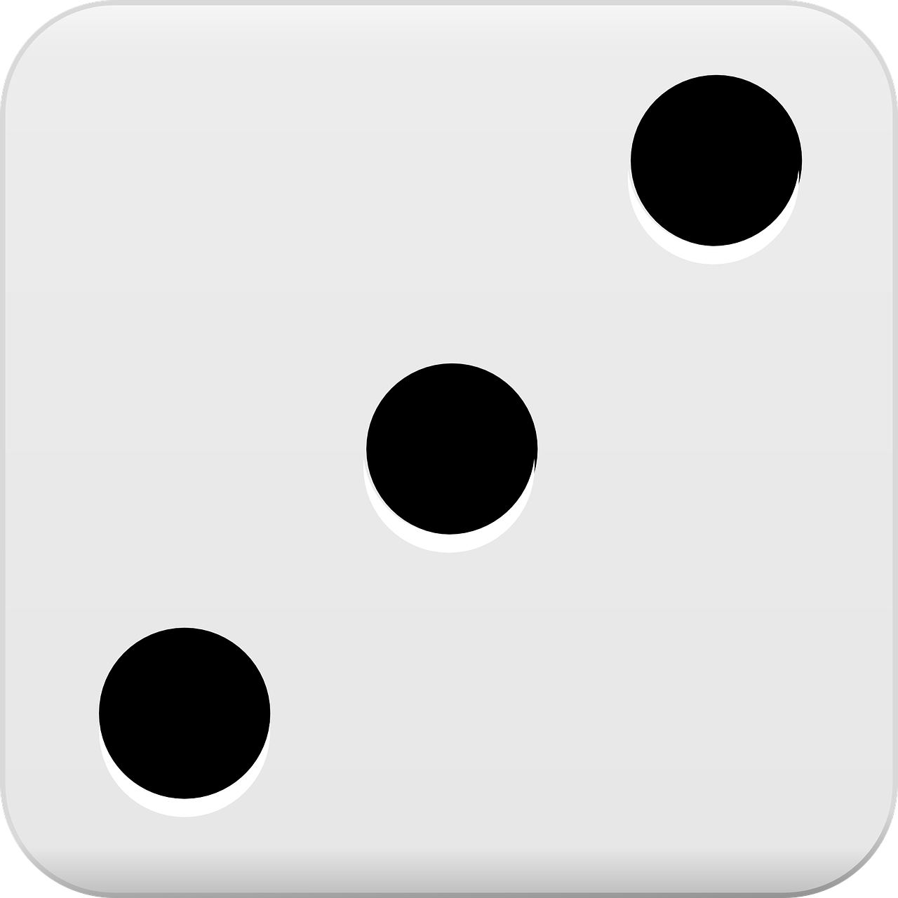
Silently read

Go to the STEM corner and build something

Work on some brain teasers

Write a book or illustrate a graphic novel

Get a game from the game closet
Enrichment Activities for Those Who Finish Early

DIG  Can you go deeper into what you just learned? | PROJECT  How could you turn this lesson into a project? | MASTER  Determine whether you have mastered the concept or just finished it
PARTNER  If someone else finishes early trade work and critique one another | TROUBLE-SHOOT  Ask students to list problems with the lesson and how to fix it | PLAN  Ask students to plan an extension lesson
EXTEND  How could you create the next level of the lesson to further teach the concept | REFLECT  How could you make your work even better? What are things that you could improve? | REFRESH  Take a quick nap to refresh your brain for the next lesson

